**Screenshots of Cloud Resources Step by Step**

**Service Hosting Frontend:**

Create Instance

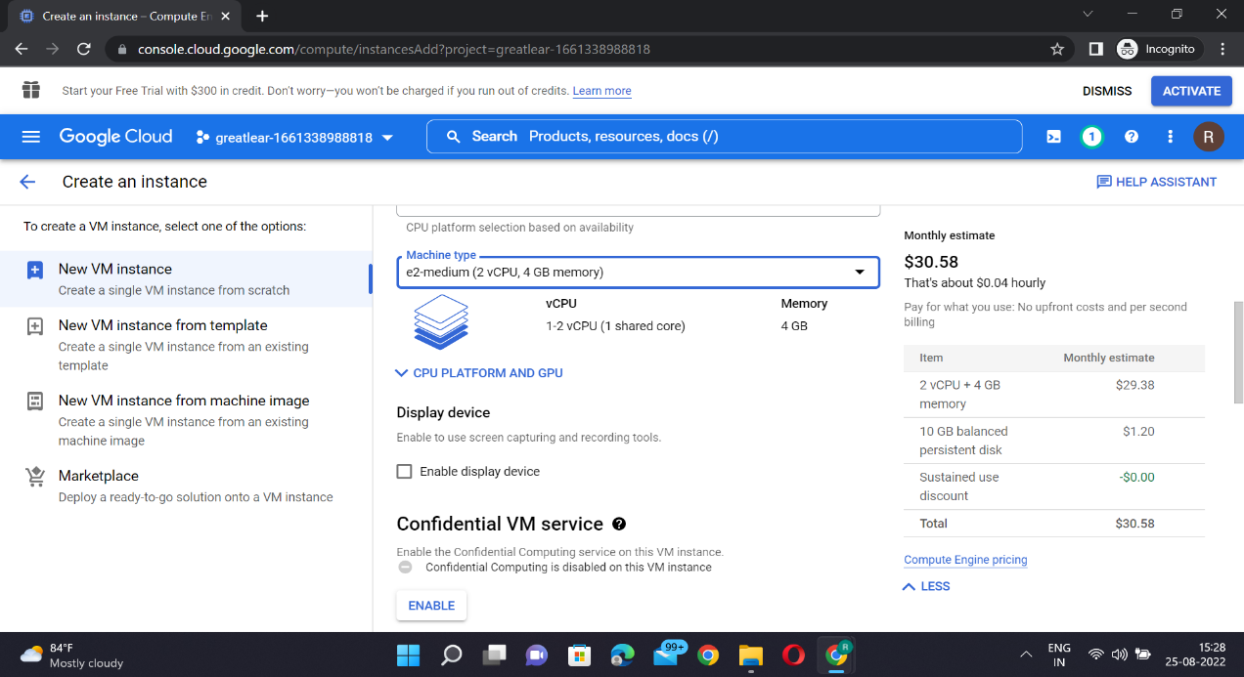

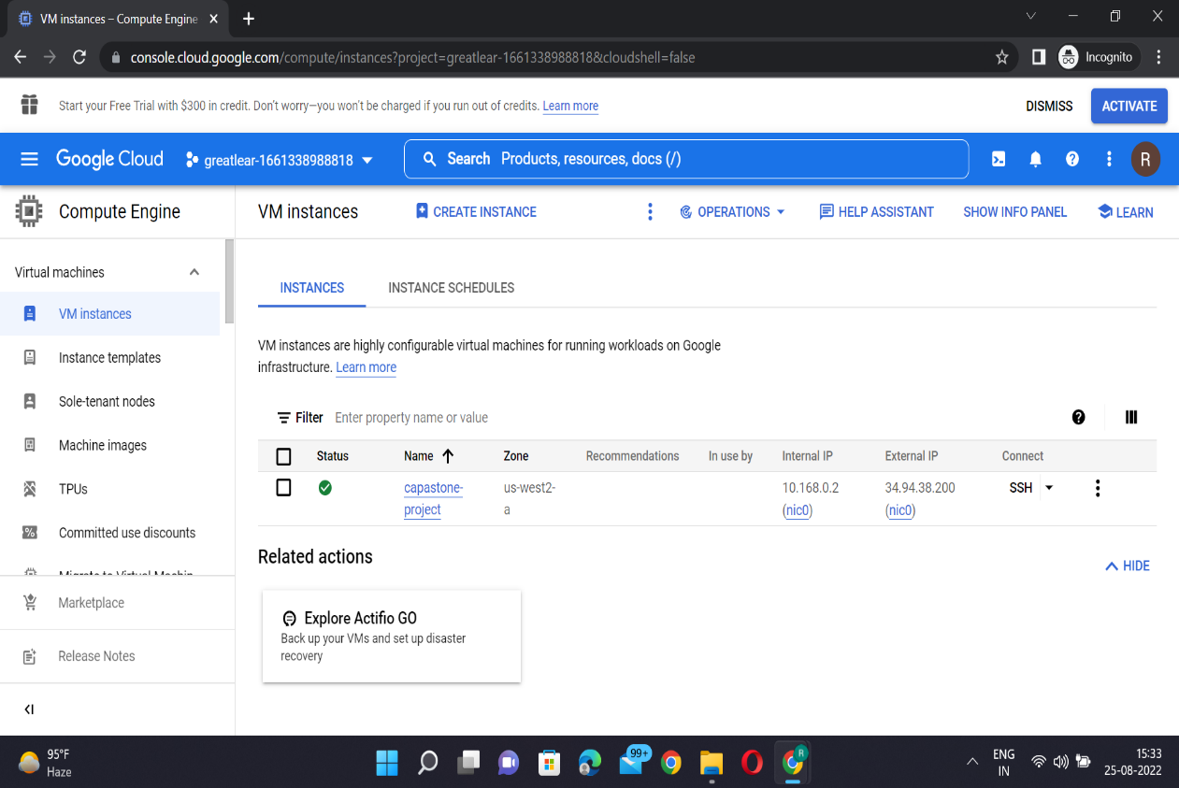

Open Terminal

Step 1- gcloud config set project projected

Step 2- echo $GOOGLE_CLOUD_PROJECT

Step 3- gcloud config set compute/zone us-west2-a

Step 4- git clone repository link

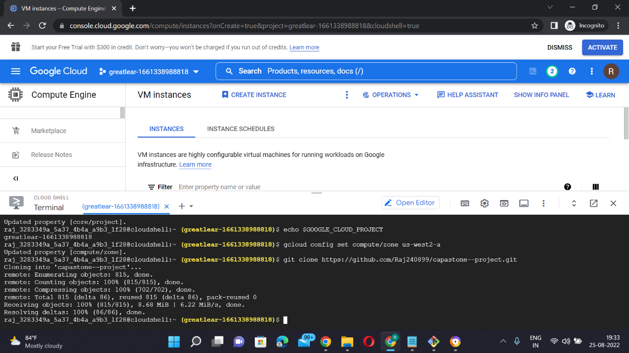

Step 5- ls

Step 6 – cd capastone-project

Step 7 – cd frontend

Step 8 – node -v

Step 9– npm -v

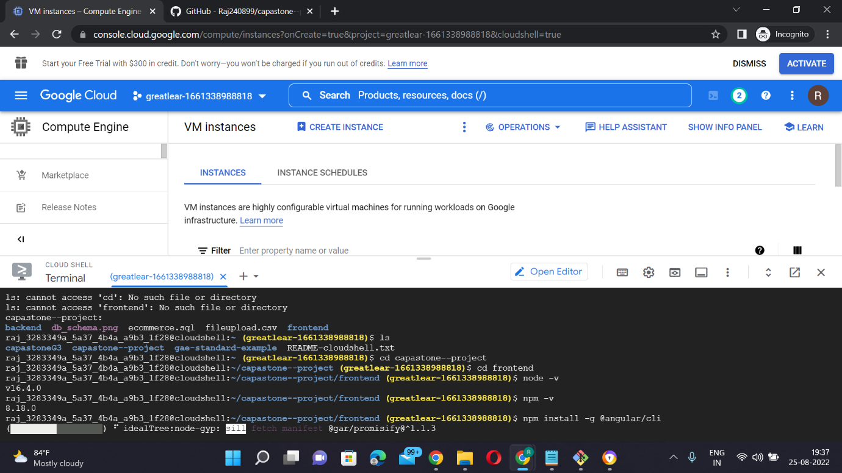

Step 10- npm install -g @angular/cli

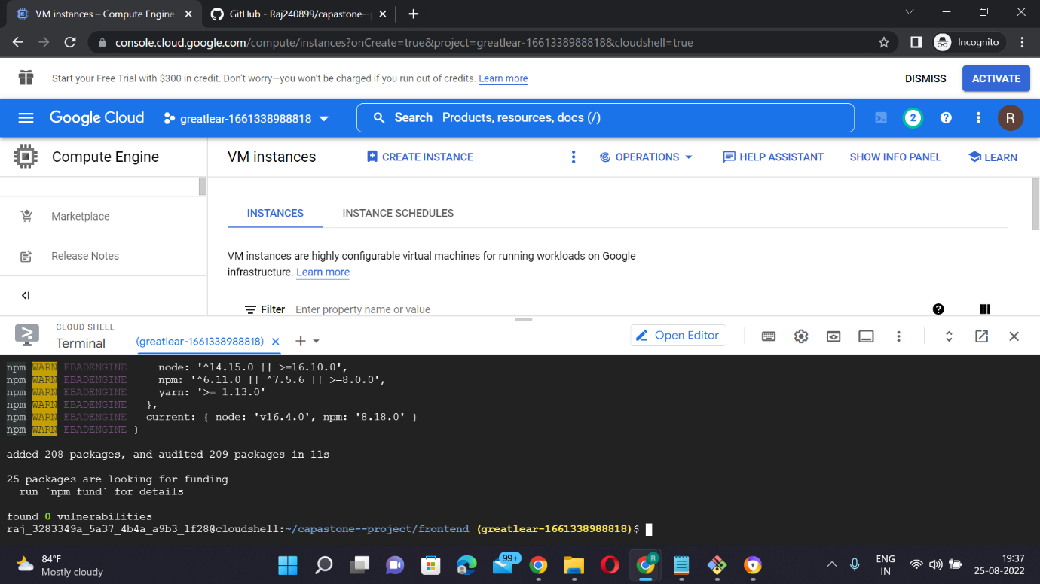

Step 11- npm install -g typescript

Step 12- nvm install 16.10

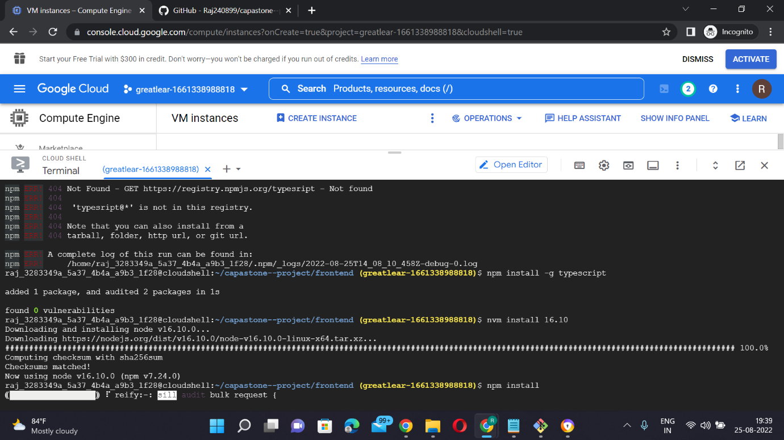

Step 13- npm install

Step 14- ng serve

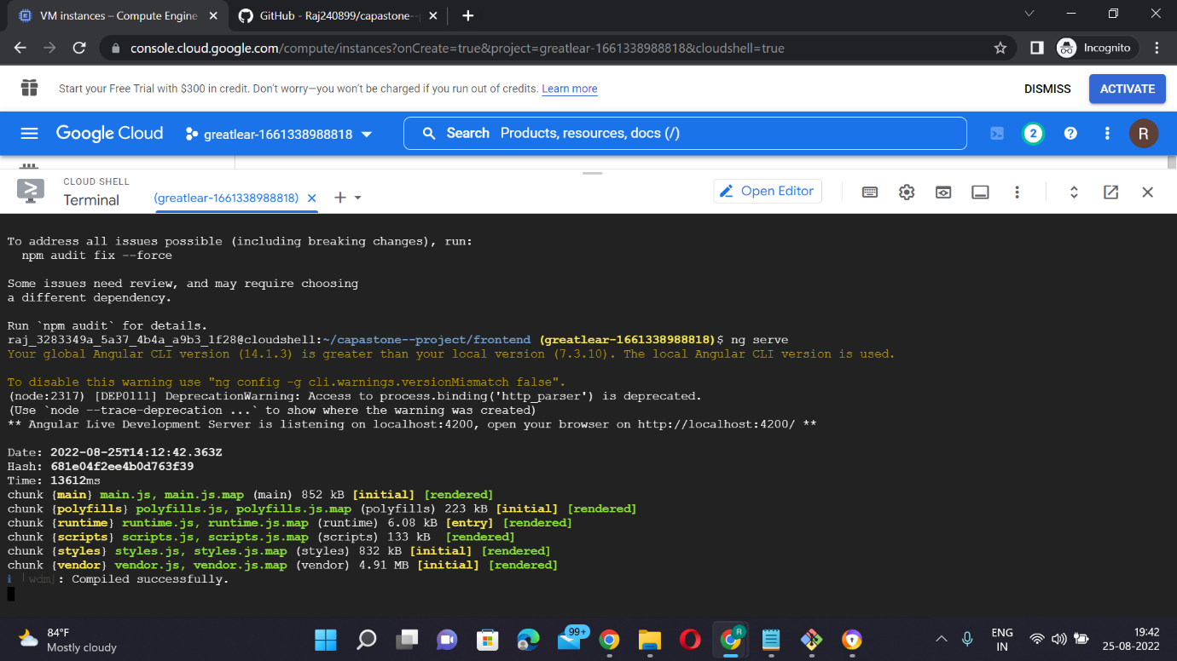

**Backend Service Hosting**

Step1- gcloud config set project porject id

Step2- echo $GOOGLE_CLOUD_PROJECT

Step3- gcloud config set compute/zone us-west2-a

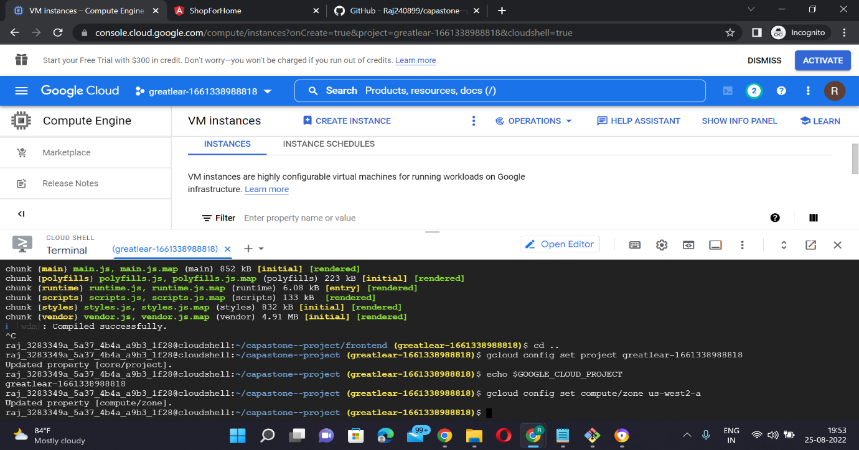

Step4- cd capastone

Step5- cd backend

Step 6- mvn -N io.takari.maven:wrapper

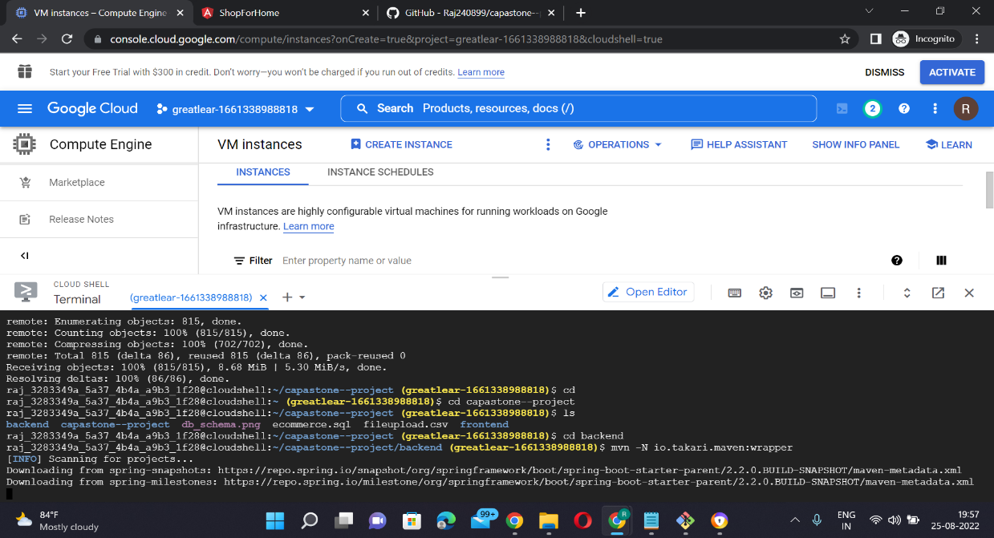

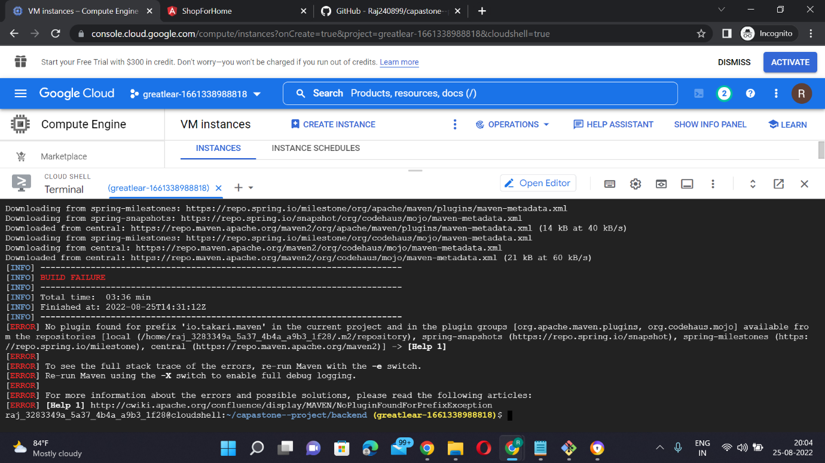

Step7- ./mvnw -DskipTests sprint-boot:run

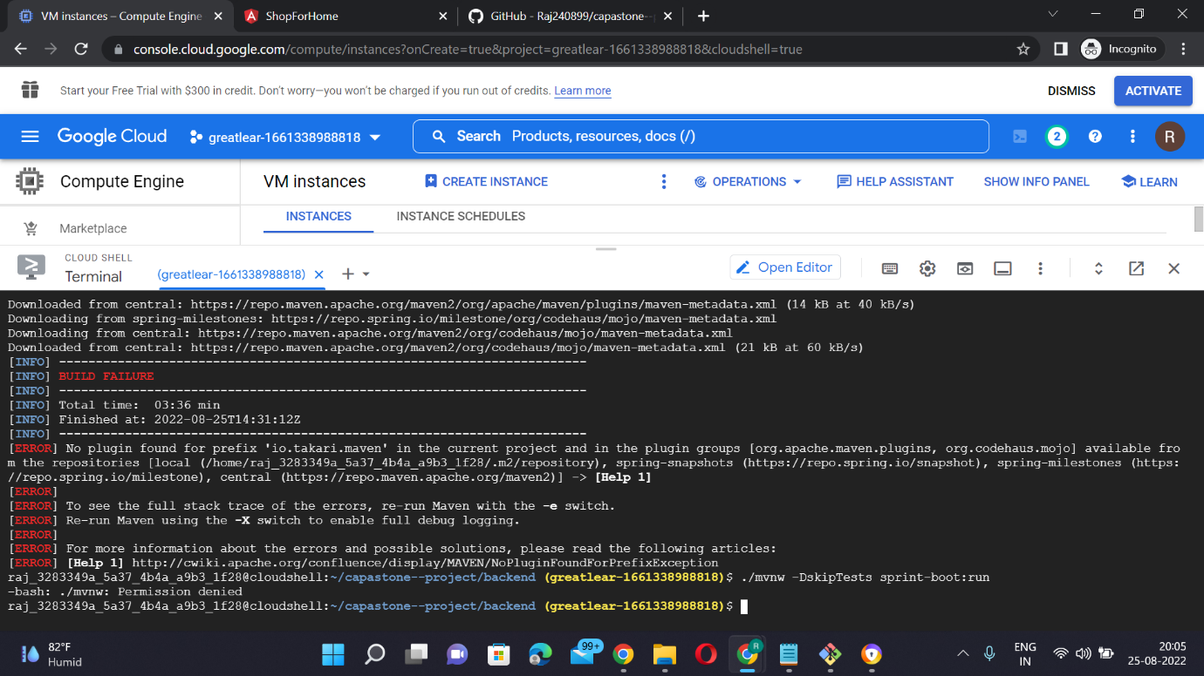

**Database Service Hosting**

search sql

click on postgress sql (our database is postgress)

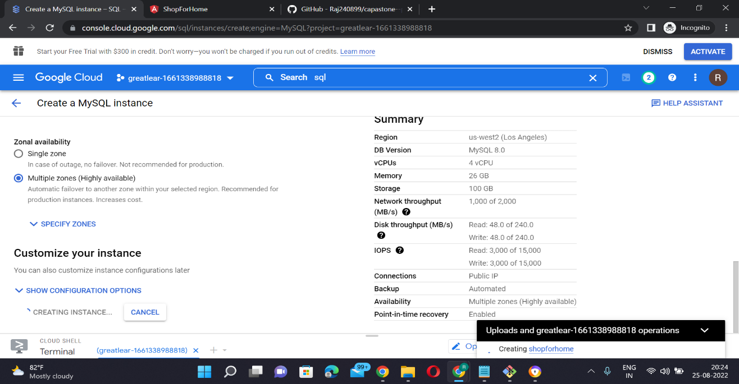

step1:-

gcloud sql connect instance --user=postgres

enter password

Step 2:- CREATE DATABASE ecommerce;

enter password of postgre

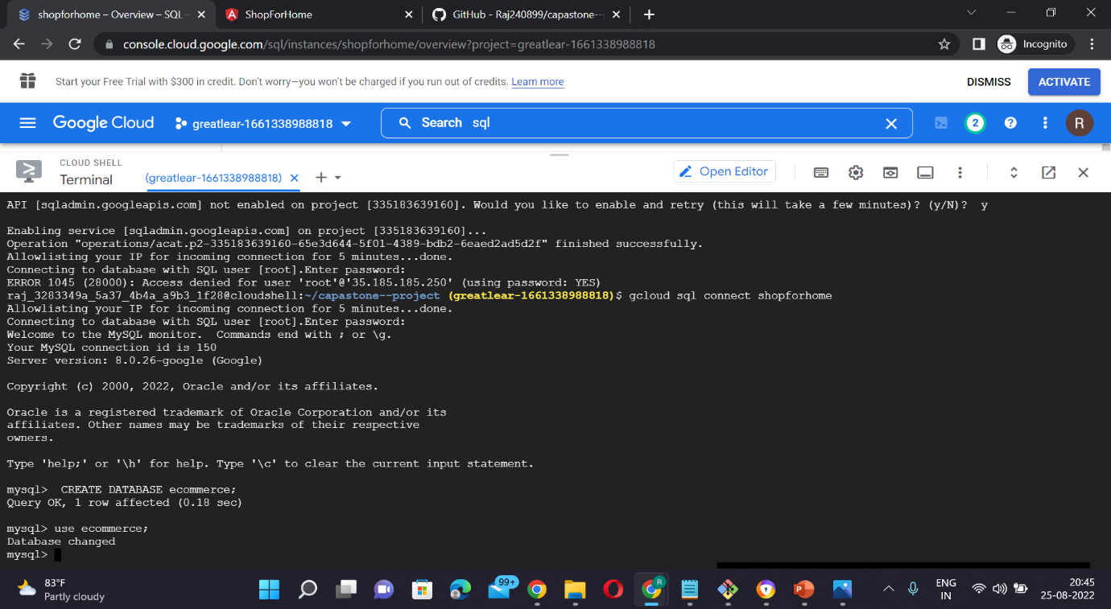

step 3:- if database is alread created then

\connect ecommerce;

step 4:- copy paste and run code

from database



